**File Extensions:**

**Tableau Data Source (.TDS file):-**

If we are connect to data source and create simple sheet and saved as

Book1.tds file, and data source saved as right click🡪 data source🡪add saved data source. If this workbook can send to our colleagues he/she may open that file it contains only structure why because,  Data source files do not contain the actual data but rather the information necessary to connect to the data source. It has only path and connection details.

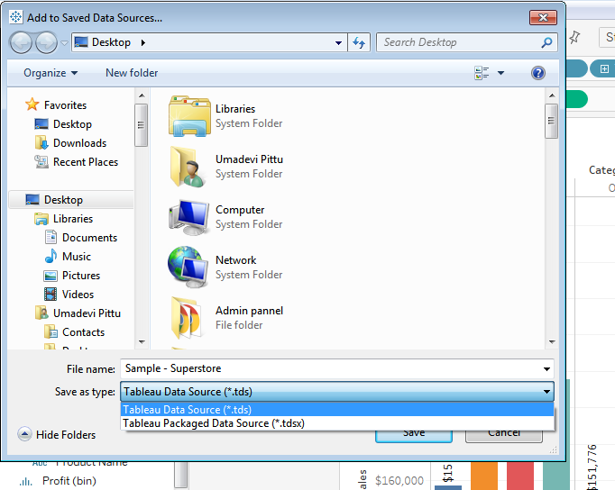

**Packaged Data Source (.tdsx)** –

Tableau packaged data source files have the .tdsx file extension. A packaged data source is a zip file that contains the data source file (.tds) described above as well as any local files data such as extract files (.hyper or .tde), text files, Excel files, Access files, and local cube files. Use this format to create a single file that you can then share with others who may not have access to the original data stored locally on your computer.

Here we can unpackaged that file it will show on one folder as

C:\Users\pumadevi\Desktop\Book.twb Files\Data\Desktop

Here it will create data source as created on one Extract file that is .TDE File it contains data and connection details. If send the workbook of your colleagues they don’t have to be send on data source file it will open directly on “live” or “extract” connection.

**Tableau Data Extract (.tde file)-**

Tableau data extract files have the .tde file extension. Extract files are a local copy of a subset or entire data source that you can use to share data, work offline, and improve database performance.

When you connect to the data source either ‘Live’ or you can ‘extract’ the data into a .tde file. Data extracts are rapidly improve the performance.

The disadvantage to using an extract is that your tableau viz is no longer pointing to the ‘Live’ data source- if that data source updates then your viz will not until you refresh the extract. Fortunately refreshing the extract is only a few clicks away or you can set up your tableau server to refresh the extract on schedule.

C:\Users\pumadevi\Desktop\Book.twb Files\Data\Desktop

Here it will create data source as created on one Extract file that is .TDE File

**Differences .TDSX and .TWBX:**

.tdsx file , this saves the data source in it in encrypted format & when you connect your workbook with .tdsx you will get the data & you do not need your data source file.

.TWBX is the packaged workbook it contains .tdsx what we have to create the workbook, but here .tdx and .tdsx are just data sources only.

**What is the difference between Tree map and Heat map:**

To visualize measures against dimensions with the help of colors and size to compare one or more dimensions & up to two measures. The layout is similar to a text table with variations in values encoded as colors. In heat map, you can quickly see a wide array of information.

In a heat map, one measure can be assigned to the color and another measure can be assigned to the size.

Heat Map:

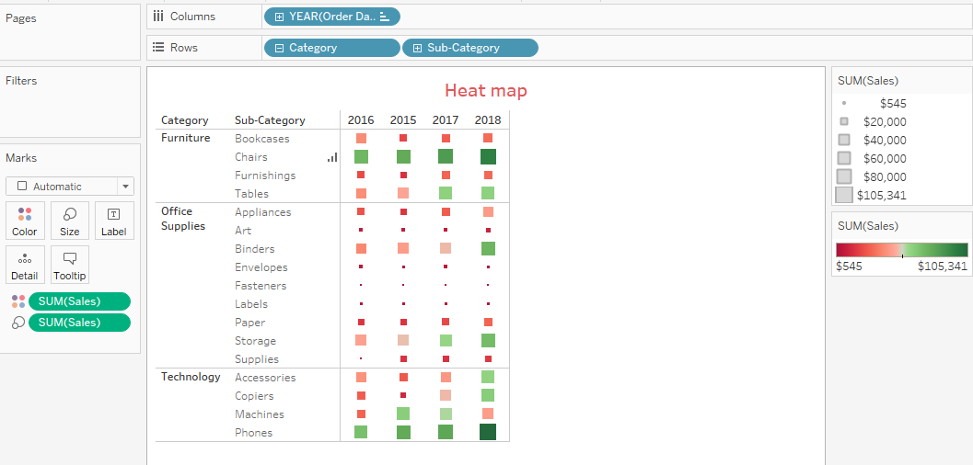

Tree map:

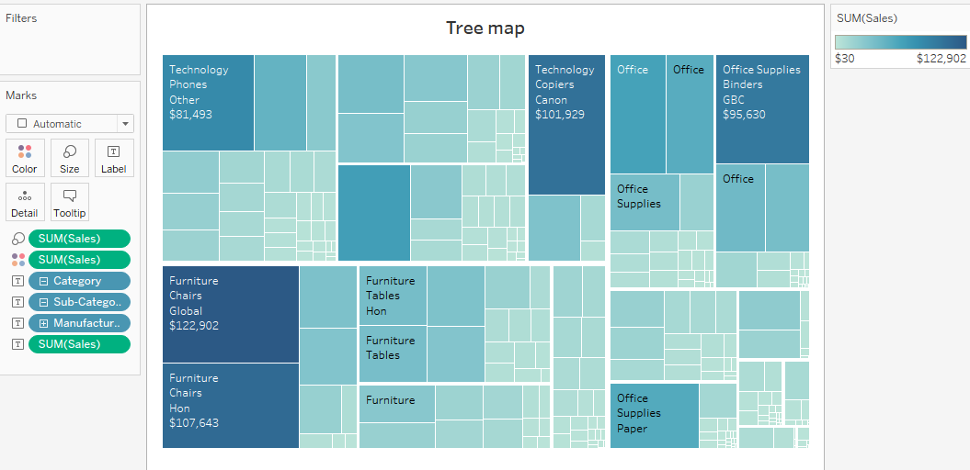

Tree maps are a relatively new feature in Tableau, first appearing in version 8.0. The ‘tree map’ is a chart type that displays hierarchical or part-to-whole relationships via rectangles. In case of hierarchical (tree-structured) data these rectangles are nested. The space in the view is divided into rectangles that are sized and ordered by a measure. Nested rectangles mean that hierarchy levels in the data are expressed by larger rectangles (above in the hierarchy) containing smaller ones (below in the hierarchy). The rectangles in the tree map range in size from the top left corner of the chart to the bottom right corner, with the largest rectangle positioned in the top left corner and the smallest rectangle in the bottom right corner.

In a tree map 1 or more dimensions & up to 2 measures are used to create such a map.